**4. Finite-State Machine for Generating Plural Forms**

**Aim:**  
To implement a finite-state machine that generates plural forms of English nouns.

**Algorithm:**

1. Define a finite set of rules for forming plurals.
2. Implement transitions based on input word ending.
3. Return the plural form based on the rules.

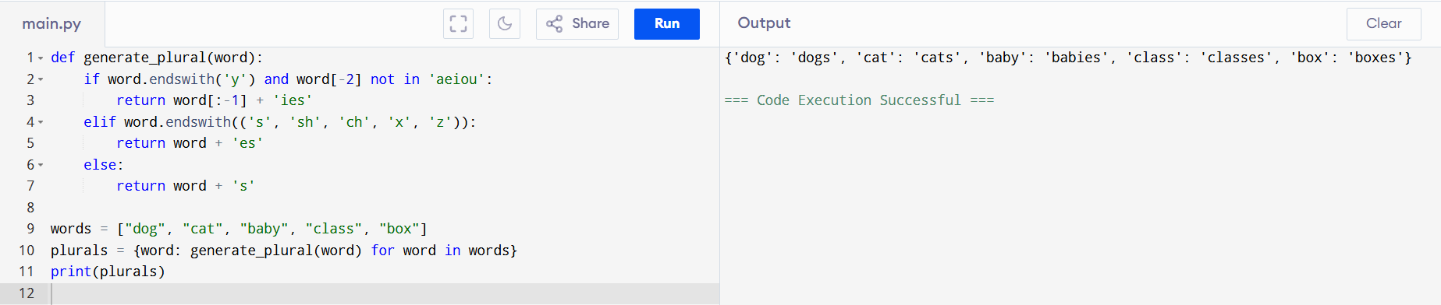

**Result:**  
The finite-state machine generates correct plural forms of nouns.